|  |
| --- |
| DATABASE SCHEMA |



FLEX: SCHEDULING APPLICATION

|  |  |  |
| --- | --- | --- |
| SAN DIEGO SOFTWARE  JANUARY 27, 2017 | | |
| **Orr Yakobi**, Project Manager  **Aidan Keogh**, Software Dev Lead  **Amanda Smith**, UI Specialist | **Anand Kumar**, Senior System Analyst  **Oliver Ganguli**, Database Specialist  **Steven Lay**, Business Analyst | **Tal Ben-Ari**, Software Architect  **Abram Trinh**, Quality Assurance  **Matt Olsen**, Database Specialist |

## 

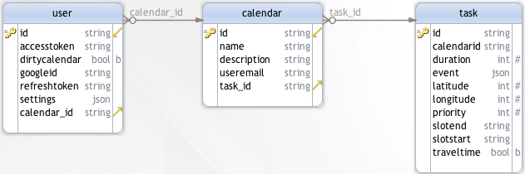

Legend

 primary key  foreign key  required field